Business Use case & Architecture:

1. Here our data source is on perm SQL server DB
2. Currently many businesses are moving from traditional db to cloud
3. So here we’ll be having 6 to 7 tables..and we migrate this to cloud
4. And here we’ll be using ADF which is an ETL tool in azure..which is used for data ingestion
5. We’ll be using Azure data lake gen2 to store the data ingested from ADF
6. Next we use azure databricks to perform transformations on our data
7. 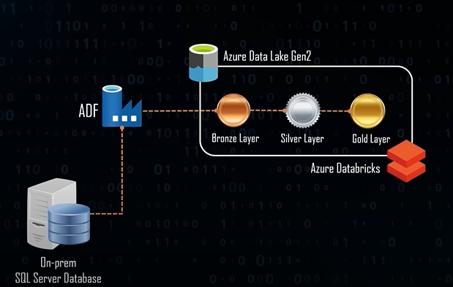
8. And inside the ADL..we’ll be having 3 layers..where bronze layer will act as source of truth(data never changes)..and next we’ll apply some transformations and store the data in silver layer…at last we’ll apply another set of transformations to even more clean the data and store them in gold layer
9. We use azure synapse analytics - It can work similar to on perm SQL database 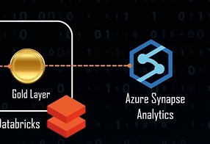
10. Now the data is completely migrated
11. To analyze the data present in synapse analytics ..we’ll be using power BI
12. Apart from that..we’ll also be using Azure Active directory for security & governance..and azure key vault to store the secrets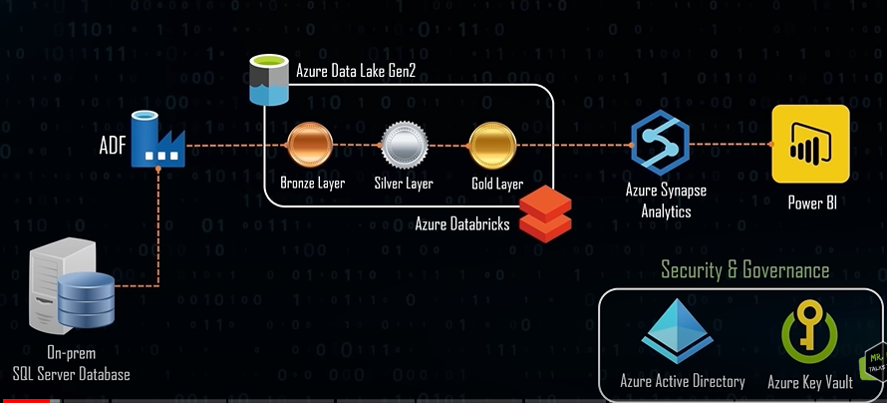
13. So here first we deal with Ingestion, Transformation, loading and reporting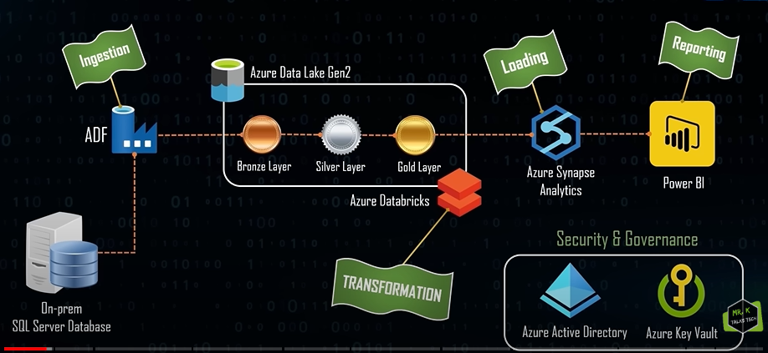
14. This is the pipeline we are dealing with
15. Also if there any new row in the OnPerm DB..then it must reflect in the Azure

Agenda

1. Here our agenda would be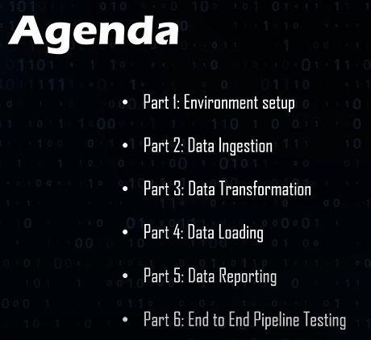

Environment setup

1. Lets go to azure portal
2. Now in azure to create any resources..we need resource group
3. Here we have created the resources which are needed for our project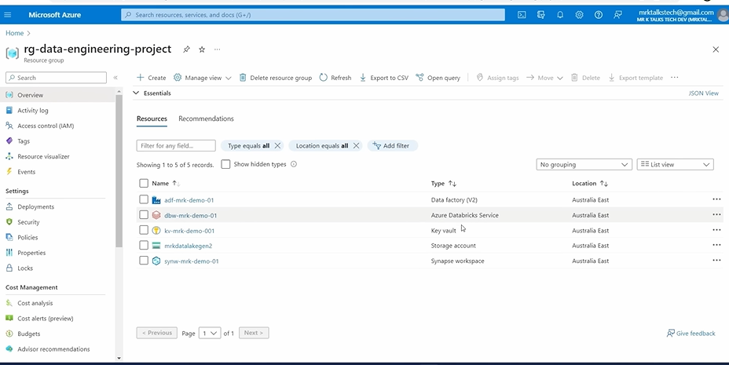
4. We’ll do identity and access management at Azure AD
5. Next we’ll check the data source
6. Here in the SSIS server 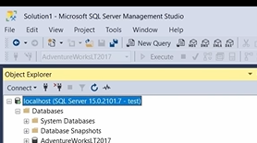 we have a db called AdventureWorksTL2017 and inside that we have tables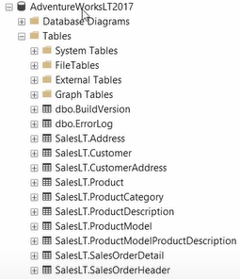here we have 2 schemas..one with dbo and other with salesLT. We are interested in SalesTL
7. Here we need to create a login for this DB..so we can use this logins while connecting to Azure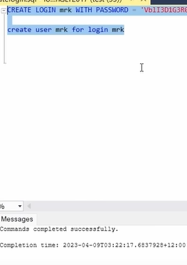
8. Now we have to assign user mrk the permissions required to access our tables…to do that we’ll assign db_datareader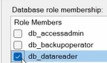
9. Now using this login details..we can login into DB thru azure
10. And we’ll store this login credentials in azure Key Vault
11. So we’ll go to our resources and go to key vault..in the left side we have secrets 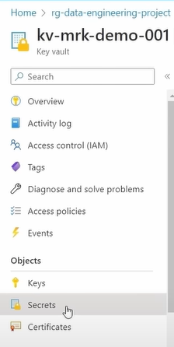
12. Next click on generate/import in KV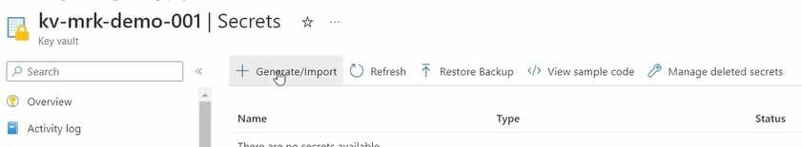
13. Here we will create a secret for username and for password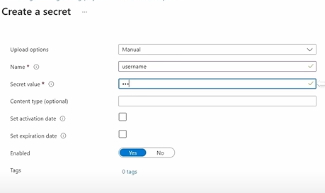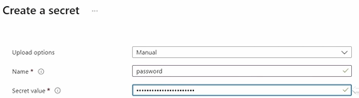
14. It is very good practise to store all the password in the Key Vault in the beginning of the project
15. So here we covered the environment setup

Data Ingestion Using ADF

1. First we’ll go to Azure Data Factory page ..inside azure Df..click on launch studio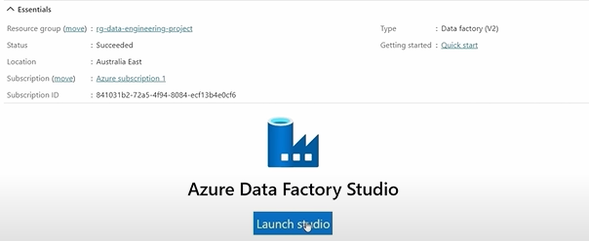
2. In Azure ..integration runtime..it helps in connecting on perm data sources
3. So first we need to install integration runtime in our local setup
4. Here we have autoresolveintegrationruntime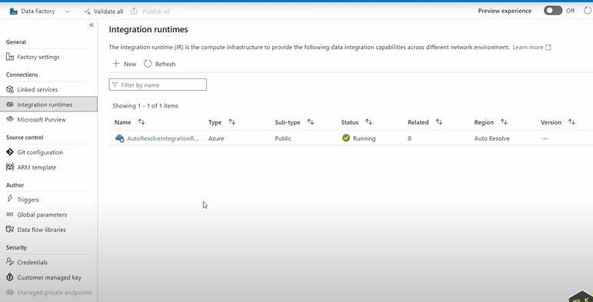which is used to connect ADF to Datalake etc
5. But to connect to on perm..we need to create a new integration run time..which is called self integration run time
6. To create it click new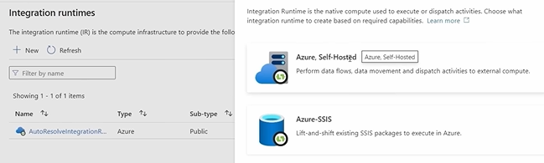
7. Click on azure self-hosted → self-hosted
8. Next give a name and desc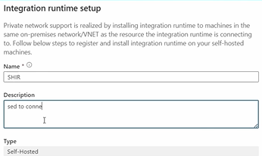
9. And we’ll be having two options here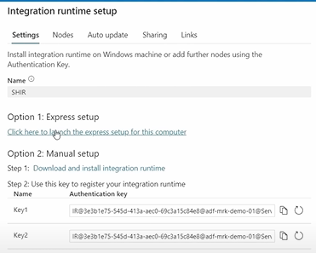we’ll choose option 1
10. Here we go ahead with express setup (Which is used to setup in our own machines)
11. We can use manual setup with keys..when we are installing integrationruntime in different machines which is not ours
12. Here we have created Self hosted integration runtime(SIHR)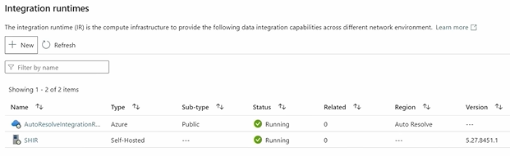
13. This means that we have connected our local machine to cloud
14. Now we have to connect to OnPerm SQL server and copy all these tables using ADF
15. Lets see how we can do with that ADF..for that first go to the author tab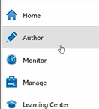
16. Now we can create a pipeline here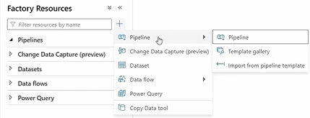
17. And after creating a pipeline..we go inside the pipeline and create new activity …which is copy data(drag copydata into white space)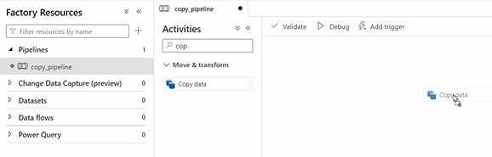
18. First we’ll copy single table using this copy data activity…we’ll copy address table first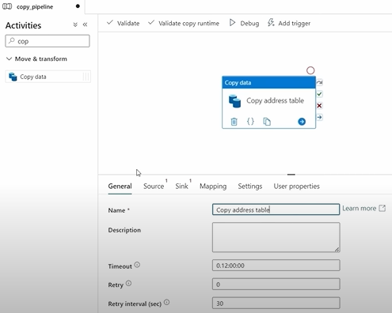
19. Here the 2 main important things is source and sink
20. So here we need to create a source dataset which replicates our address table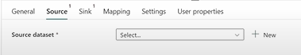
21. As it is OnPerm SQL Server DB..we choose data store as SQL server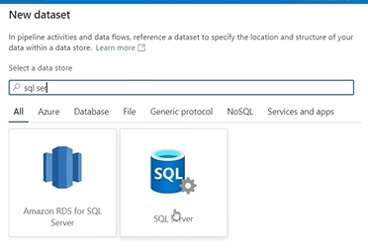
22. Next we set name as address
23. And to connect to any sort of DB ..we need to have some connection string(Linked Service) 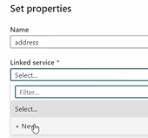
24. Now here we’ll give our linkedservice a name…and server name(of our onPerm Sql) and database name 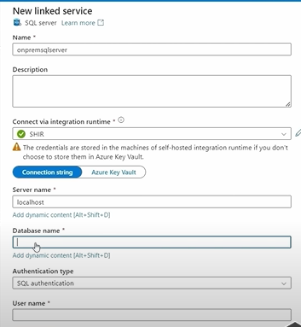
25. After giving the db name..we have to give credentials
26. So we’ll retrieve our credentials thru Azure key vault..for this ..we have to link our azure KV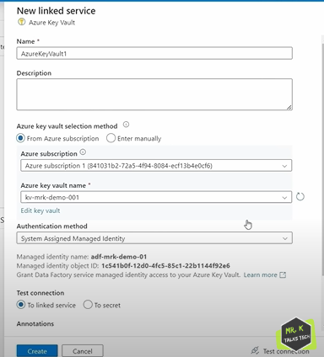
27. After successfully linking our Azure KV…we may get secret name failed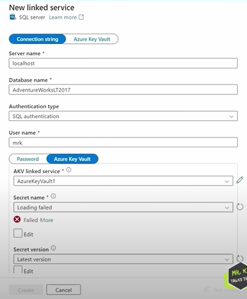as ADF dont have required permission to access the secrets
28. So we’ll go to Azure KV → Access policies..and we’ll create a new access policy for ADF 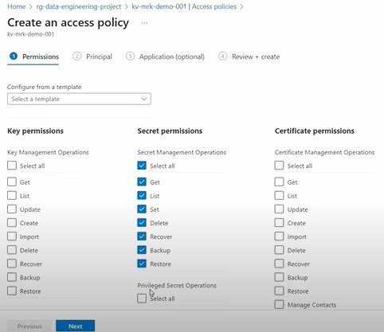
29. Next we give principle (which is our ADF)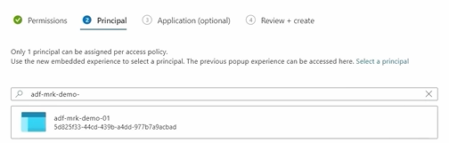
30. Here we can see now our ADF has required permissions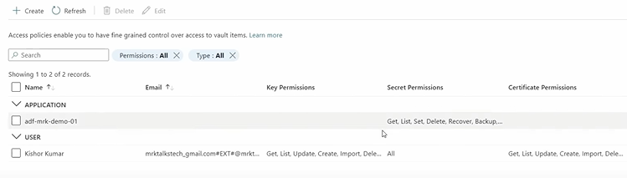
31. Now we can access our 2 secrets thru our ADF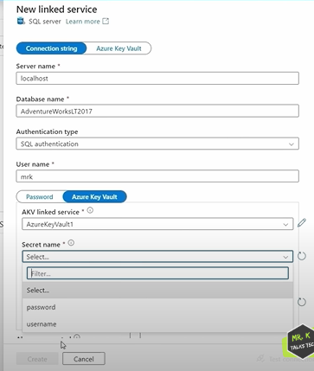
32. Now we have given all the required things(SQL server,authentication etc) got linked service